|  |
| --- |
| **JDN Standards – Sever & vCenter Installation** |

Introduction 2

User & password guidelines 2

Standard configuration 3

Dell VRTX 4

VRTX Identification 4

VRTX Indicators (buttons, LEDs and LCD) 5

VRTX configuration 7

On-board VRTX storage configuration 8

Dell R430 10

R430 Identification 10

Front Panel 10

Back Panel 11

R430 Configuration 12

HP DL20 15

DL20 Identification 15

Front panel 15

Back panel 16

DL20 Configuration 17

Firmware 19

Dell VRTX 19

Dell R430 19

HP DL20 19

Installation preparation 20

VMware ESXi 6.5 21

USB preparation 21

VMware ESXi 6.5 21

Dell VRTX storage performance tweaks 23

Dell430 / DL20 >> Configure all Datastores 24

VRTX >> ESXi Configure Datastores 29

DC deployment 30

VMWare vCenter appliance 6.5 31

Template/OVA deployment 37

ISO deployment 39

VM deployment 40

Domain maintenance 42

Autostart VM’s 44

Configuring XX-MGMT01 44

Configure ESX 46

Test 48

# Introduction

This document describes the technical setup of the standards v1.1 as defined for JDN deployments in 2018. This document is specific to JDN ships & remote sites.

This document focuses on the installation of vCenter.

Dell VRTX solution used for the large & medium-sized deployments (as described in the deployment guidelines), the Dell R430 solution used for the small sized deployments and the HP DL20 for specific vessel deployments.

# User & password guidelines

The “**root**”, “**administrator**” & “**admin**” user accounts & passwords are reserved for installation and SA/SE usage. Which of the three user names is used can depend on the system in question. They should never be communicated to the crew (even the Captain).

A separate “**adl_tse**” user (with the same user rights) will be created for TSE usage. This will enable TSE to always use the same login on all devices. Ideally, TSE should never use the “root”, “administrator” & “admin” passwords after the installation has been concluded and the normal support cycle has started.

A separate “**adl_local**” user will be created to be communicated to the Captain (and potentially ELEC). Depending on the device in question, only restricted rights will be granted to the adl_local user.

Passwords chosen will be different for each ship or site, and as such should be diligently registered in RDM for each ship or site.

# Standard configuration

* Dell VRTX
  + 2 to 3 M630 (previously M520) blades with each:
    - two Xeon CPUs
    - 96GB RAM
    - Two 600GB SAS 2.5” disks
  + Passthrough networking module
  + Redundant (S)PERC
  + Redundant CMC
  + 4 1100W PSUs
  + 16 600GB SAS 2.5” disks for normal Medium & Large setups and 25 600GB SAS 2.5” disks for Large Offshore
* Dell R430
  + two Xeon CPUs
  + 96GB RAM
  + Eight 1.2TB 10k SAS 2.5” disks
  + PERC H730
  + Redundant PSUs
  + iDRAC Enterprise
* HP DL20
  + One Xeon CPUs
  + 64GB RAM
  + Four 1.8TB 10k SAS 2.5” disks
  + Smart Array P440 Controller
  + Redundant PSUs
  + Ilo Advanced

Consult the deployment guidelines for more information:

<http://meso.jandenul.com/meso-webtop/drl/objectId/090236ed824d5fa5>

# Dell VRTX

## VRTX Identification

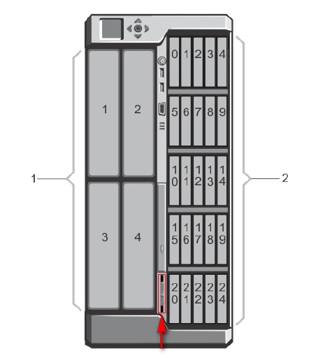

1. On the left: Blade numbers
2. On the right: 2.5” disk numbers

* Marked in red: information tag with JDN ID tag & Dell service tag location (pull out)

## VRTX Indicators (buttons, LEDs and LCD)

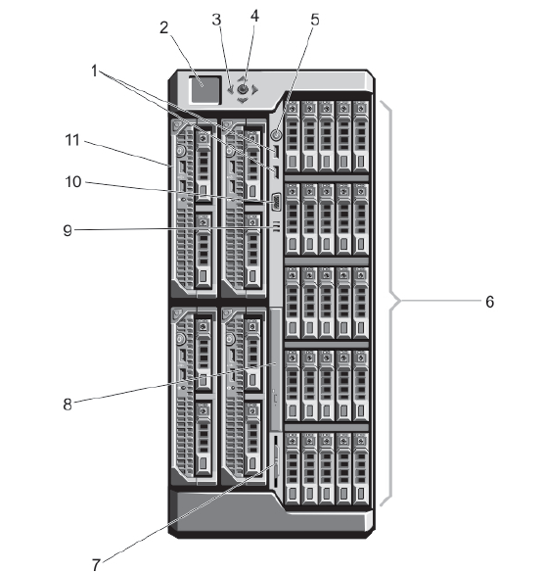

1. USB connectors
2. LCD panel
3. LCD menu scroll buttons
4. Select/Enter
5. Power button
6. Hard drives
7. Information tag (Dell service tag & JDN tag)
8. Optical drive (not present)
9. Vents
10. Video connector
11. Server modules

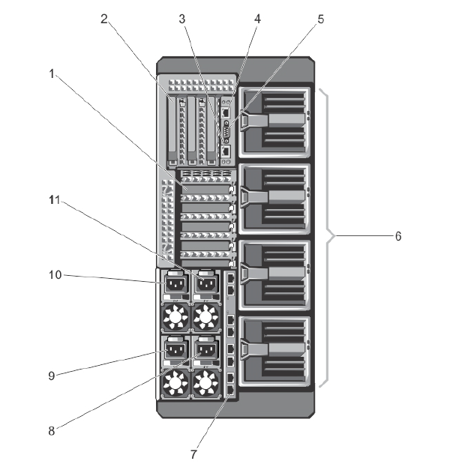

1. Low profile PCIe expansion card slots
2. Full height PCIe expansion card slots
3. CMC NIC port 2
4. CMC NIC port 1
5. Serial connector
6. Blower modules
7. I/O module ports (passthrough in our standard)
8. Power supply PSU4
9. Power supply PSU3
10. Power supply PSU1
11. Power supply PSU2

(PSU 1 & 2 and PSU 3 & 4 are paired if power grid redundancy mode is activated)

## VRTX configuration

Turn on the Chassis and Blades.

**CMC (Dell VRTX):**

* Connect both CMC network ports to the network.
* Configure CMC IP using the built-in *Control Panel LCD* (x.x.x.250)
* Do not register IP in DNS
* Start the VRTX chassis
* Do not configure iDRACs or start the blades yet.
* Rotate LCD display to rack mode if applicable
* SSH to the CMC IP entering “root” “calvin” as credentials.
* Copy/Paste the generated CMC Configuration from the Excel
* Log into the CMC by browsing to its IP and entering it’s new credentials. You will be prompted to modify the default password. Be sure to save this password in a safe location
  + In the top menu, select “Alerts”.
    - Under the “Chassis Events” tab:
      * Make sure “Enabled” is checked (Apply if needed).
      * For “System Health”, “Storage” & “Audit”, select all “Critical” and “Warning” events, and select all Email, SNMP & Remote Sys Log.
      * Press “Apply”.
  + In the top menu, select “Setup”.
    - Under the “Chassis Backup” tab: Click “Save” to Save Chassis Configuration. Keep this file in case you have to restore it while installing the setup.

**iDRAC (M630 blades):**

* Start the blades
* SSH to the iDRAC’s
* Copy/Paste each generated Idrac Configuration from the Excel to the corresponding blade

*Note: The CMC NICs have no VLANs configured. The switches should tag them as Admin_Trust.*

## On-board VRTX storage configuration

The standard storage configuration of the disks keeps 2 disks as global host spares & puts the remainder of the disks in Raid 6.

Virtual disks are created with the size of 1,5 TB maximum (ESX best practice). Naming conventions are VirtualDisk*X*R*6*, where the *X* is an incrementing number and *6* is the used raid level.

All these virtual disks are made available to all ESXi servers.

Execute the following Virtual Disk creation steps if you use the **25 disk setup**:

* + In the side menu, select “Storage” > “Virtual Disks”.
  + Remove existing Virtual Disks
  + At the top of the “Virtual Disks” screen, select “Create”.
  + First scroll down and select the physical Internal Disks you wish to use. This configuration leaves the first disk unselected (for later use as hot spare). Then select the first 12 disks following the first for the first array and the remaining 12 (except the first) for the second array.
  + Scroll back up and enter the name of your virtual disk. This is Ar1VirtualDisk1 (for Array 1 Virtual Disk 1), where 1 is the sequence number for the array & the virtual disk.
  + Select raid level. Typically Raid 6.
  + Set capacity to 2 TB.
  + Scroll to the bottom of the page & click “Create Virtual Disk”.
  + Repeat the Virtual Disk creation steps until all capacity has been used for virtual disks using the following sizes & names:
    - Ar1VirtualDisk1: 2TB (used for the vCenter, DC & templates)
    - Ar1VirtualDisk2: 2TB (used for servers)
    - Ar1VirtualDisk3: 1.55 TB (spare)
    - Ar2VirtualDisk1: 2TB (used for clients)
    - Ar2VirtualDisk2: 2TB (used for the file server)
    - Ar2VirtualDisk3: 1.55 TB (spare)
* Allowing multiple assignment of Virtual Disks to blades:
  + In side menu, select “Storage”.
  + In the top menu, select “Setup”.
  + Scroll down, select “Multiple Assignment” and press “Apply”
* Configure hot spares:
  + In side menu, select “Storage” > “Physical Disks”.
  + In the top menu, select “Setup”.
  + Use the drop down to set Physical disks 0:0:0 & 0:0:1 as “Global Hot Spare” if you use the 16 disk setup, and only Physical disks 0:0:0 if you use the 25 disk setup.
* Go to "Storage > Virtual Disks > Manage" and make sure write policy “Write Back” is enabled. If not select "Edit Policy: Write Cache" and pick "Write Back" instead of “Write Through” for all your virtual disks. The change above will be carried out immediately, but it is still suggested to reset the CMC once more under "Chassis Overview > Power > Control" with "Reset CMC (warm boot)".
* Boot your previously shut down blades.

# Dell R430

## R430 Identification

### Front Panel

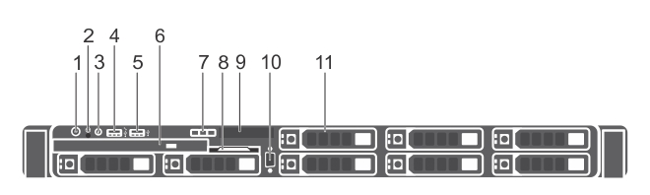

1. Power button
2. NMI button
3. System identification button
4. USB management port or iDRAC managed USB port
5. USB port
6. Optical drive
7. LCD menu buttons
8. Information tag
9. LCD panel
10. Video connector
11. Hard drives

### Back Panel

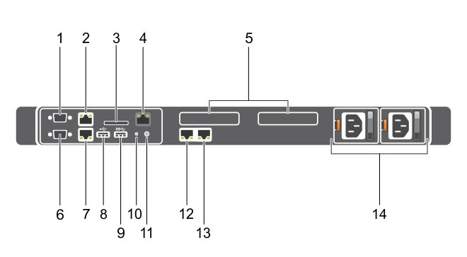

1. Serial connector
2. Ethernet connector 1
3. vFlash card slot (optional)
4. iDRAC port (optional)
5. PCIe expansion card slots (2)
6. Video connector
7. Ethernet connector 2
8. USB connector
9. USB connector
10. System identification button
11. System identification connector
12. Ethernet connector 3
13. Ethernet connector 4
14. Power supply unit (PSU1 and PSU2)

## R430 Configuration

Turn on the R430 server.

Configure system:

* Start putty and connect to the R430’s default IP: 192.168.0.120 as we will set a static IP from the config or set the static IP immediately on the display and start your putty connection to the new IP.
* Logon with default root account and password calvin.
* Open the configuration Excel “Dell-CMC-IDRAC vX.xlsx” from location [\\jdn-file01\Ict_New_Standard_Sites_Vessels\Scripted Install\CMC - IDRAC (Standaarden 1.1)](\\\\jdn-file01\\Ict_New_Standard_Sites_Vessels\\Scripted Install\\CMC - IDRAC (Standaarden 1.1))
  + After entering the number in the Selected site box, adjust the following manual parameters:
    - root
    - adl_tse
    - adl_local
    - srv_monitor_xxx (only for sites)
    - aantal blades (leave ‘3’ for R430)
    - Vessel or office
  + If this setup has a cold spare, you need increase the IP address by ‘1’ and change the hostname to XX-ESX02
* Copy/Paste the configuration in your putty connection to the R430
* If settings are applied, proceed your configuration with the following commands to create the virtual disks (execute one by one!!)
  + Analyze your current virtual disks (default created by manufacturer or created from a previous installation)

*Racadm get STORAGE.VirtualDisk*

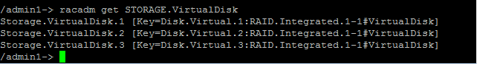

* + Delete these virtual disks (by referring to their full key name)

*Racadm RAID deletevd:<name of disk>*

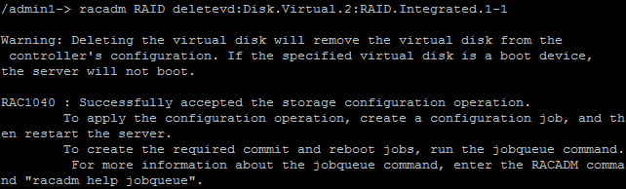

* + After executing the commands to delete your current disks one by one, the tasks are pending to be committed. Apply these settings by the following jobqueue command

*racadm jobqueue create RAID.Integrated.1-1 -r pwrcycle*

* + 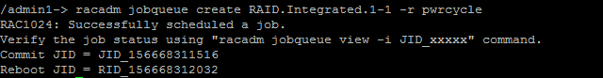
  + After the reboot it can take up to 10 minutes before the task is completed. To track the status:

*Racadm jobqueue view*

* + If the percentage is 100, start the following commends
  + Create the new virtual disks (execute one by one!!)

*racadm raid createvd:RAID.Integrated.1-1 -rl r6 -wp wb -rp ara -ss 64k -pdkey:Disk.Bay.0:Enclosure.Internal.0-1:RAID.Integrated.1-1,Disk.Bay.1:Enclosure.Internal.0-1:RAID.Integrated.1-1,Disk.Bay.2:Enclosure.Internal.0-1:RAID.Integrated.1-1,Disk.Bay.3:Enclosure.Internal.0-1:RAID.Integrated.1-1,Disk.Bay.4:Enclosure.Internal.0-1:RAID.Integrated.1-1,Disk.Bay.5:Enclosure.Internal.0-1:RAID.Integrated.1-1,Disk.Bay.6:Enclosure.Internal.0-1:RAID.Integrated.1-1,Disk.Bay.7:Enclosure.Internal.0-1:RAID.Integrated.1-1 -name VirtualDisk1R6 -size 1536g*

*racadm raid createvd:RAID.Integrated.1-1 -rl r6 -wp wb -rp ara -ss 64k -pdkey:Disk.Bay.0:Enclosure.Internal.0-1:RAID.Integrated.1-1,Disk.Bay.1:Enclosure.Internal.0-1:RAID.Integrated.1-1,Disk.Bay.2:Enclosure.Internal.0-1:RAID.Integrated.1-1,Disk.Bay.3:Enclosure.Internal.0-1:RAID.Integrated.1-1,Disk.Bay.4:Enclosure.Internal.0-1:RAID.Integrated.1-1,Disk.Bay.5:Enclosure.Internal.0-1:RAID.Integrated.1-1,Disk.Bay.6:Enclosure.Internal.0-1:RAID.Integrated.1-1,Disk.Bay.7:Enclosure.Internal.0-1:RAID.Integrated.1-1 -name VirtualDisk2R6 -size 1536g*

*racadm raid createvd:RAID.Integrated.1-1 -rl r6 -wp wb -rp ara -ss 64k -pdkey:Disk.Bay.0:Enclosure.Internal.0-1:RAID.Integrated.1-1,Disk.Bay.1:Enclosure.Internal.0-1:RAID.Integrated.1-1,Disk.Bay.2:Enclosure.Internal.0-1:RAID.Integrated.1-1,Disk.Bay.3:Enclosure.Internal.0-1:RAID.Integrated.1-1,Disk.Bay.4:Enclosure.Internal.0-1:RAID.Integrated.1-1,Disk.Bay.5:Enclosure.Internal.0-1:RAID.Integrated.1-1,Disk.Bay.6:Enclosure.Internal.0-1:RAID.Integrated.1-1,Disk.Bay.7:Enclosure.Internal.0-1:RAID.Integrated.1-1 -name VirtualDisk3R6 -size 1536g*

*racadm raid createvd:RAID.Integrated.1-1 -rl r6 -wp wb -rp ara -ss 64k -pdkey:Disk.Bay.0:Enclosure.Internal.0-1:RAID.Integrated.1-1,Disk.Bay.1:Enclosure.Internal.0-1:RAID.Integrated.1-1,Disk.Bay.2:Enclosure.Internal.0-1:RAID.Integrated.1-1,Disk.Bay.3:Enclosure.Internal.0-1:RAID.Integrated.1-1,Disk.Bay.4:Enclosure.Internal.0-1:RAID.Integrated.1-1,Disk.Bay.5:Enclosure.Internal.0-1:RAID.Integrated.1-1,Disk.Bay.6:Enclosure.Internal.0-1:RAID.Integrated.1-1,Disk.Bay.7:Enclosure.Internal.0-1:RAID.Integrated.1-1 -name VirtualDisk4R6*

* + Apply settings and reboot system

*racadm jobqueue create RAID.Integrated.1-1 -r pwrcycle*

* Enable alerts for configuration, system health and storage

*racadm eventfilters set -c idrac.alert.storage.critical -a none -n email*

*racadm eventfilters set -c idrac.alert.system.critical -a none -n email*

*racadm eventfilters set -c idrac.alert.config.critical -a none -n email*

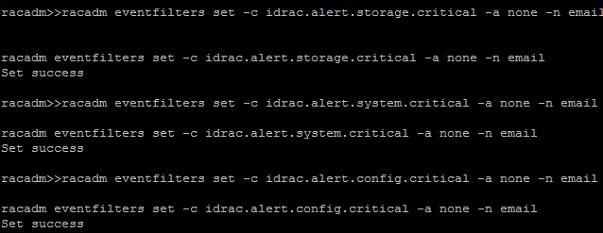

* Login to the iDRAC (x.x.x.250) to adjust the host name on the LCD screen
  + Go to Overview > Hardware > Front Panel
    - Under LCD Settings:  
      Set Home Message User Defined: <prefix>-ESX01 JDN-<number>

# HP DL20

## DL20 Identification

### Front panel

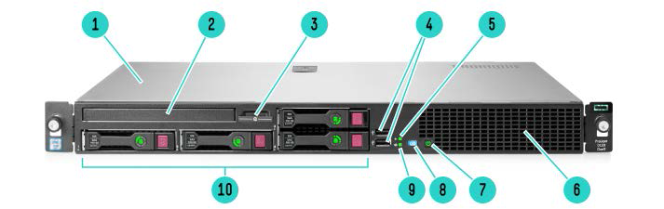

1. Access Panel
2. Optical Drive
3. Serial number/iLO information pull tab
4. 2 USB 2.0 connectors
5. Health LED
6. Front 2 Fan Assembly
7. Power On/Standby button and system power LED button
8. UID LED
9. NIC status LED
10. Hard Drive Bays

### Back panel

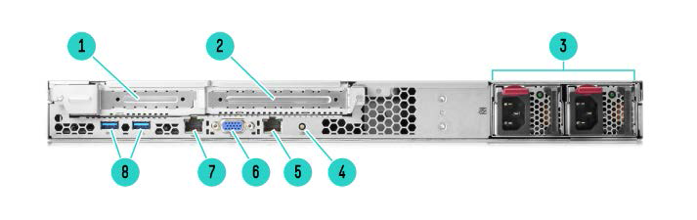

1. Expansion Slot 1, PCIe x 8 (With 2 Port Nic Installed)
2. Expansion Slot 2, PCIe x 16
3. Redundant Power Supply (only on SFF Chassis)
4. UID LED
5. NIC Connector 2
6. Video Connector
7. NIC1/shared iLO connector
8. USB 3.0 Connector

## DL20 Configuration

Connect with keyboard and Monitor and enter the BIOS (F9 or F10 keys, see below).  
  
Configure system:

* F9 System Utilities
  + System Configuration
    - BIOS/Platform Configuration (RBSU)
      * System Options
        + SATA Controller Options

Embedded SATA Config => Enable SATA AHCI Support

* + - * Boot Options
        + Boot Mode => Legacy BIOS Mode
      * Network Options
        + Network Boot options

Embedded Lom 1 Port 1 => Disabled

* + - * Power Management
        + Power Profile => Maximum Performance
    - ILO 4 Configuration
      * Network Options
        + DHCP Enable => OFF
        + DNS Name => XX-ILO01
        + IP Address => 10.X.X.250
        + Subnet => 255.255.255.0
        + Gateway => 10.X.X.1

Reboot the server. It may reboot 2 times when AHCI Sata is enabled.

Configure ILO:

* Connect to the ILO on 10.XX.XX.250, with Administrator and the password mentioned on the server tag.  
  Configure all settings below and do not forget to submit/apply between pages!
  + Network > Shared Network Port
    - General
      * iLO Hostname: XX
      * Domain Name: ILO01
    - IPv4
      * Change the Primary DNS Server: 10.XX.XX.11
    - SNTP
      * Propagate NTP Time to Host
      * Primary Time Server:10.XX.XX.11
      * Time Zone: Europe/Dublin (GMT)
  + Administration > User Administration
    - Administrator > Edit User
      * Change password
    - Add adl_tse
      * Select all user permissions
    - Add adl_local
      * Select “Virtual Power and reset” permission
  + Administration > Access Settings
    - Set Servername XX-ILO01.XX.Situs
  + Administration > Management
    - SNMP Settings
      * Read Community: SNMP-RO
    - AlertMail
      * Email Address: [ict-servicedesk@jandenul.com](mailto:ict-servicedesk@jandenul.com)
      * Sender Domain : XX.jandenul.com
      * SMTP Port: 25
      * SMTP Server: 10.XX.XX.17

Exit all and reboot

Configure disks:

* F10 Intelligent Provisioning
  + Smart Storage Administrator
    - Smart Array P440
      * Configure
        + Select All Disks >> Create Array / Logical Drive  
          Create 3 drives here:  
          RAID5 => Custom Size => **1.5TB** => Defaults =>

Click “Create Logical Drive” again.

RAID5 => Custom Size => **1.51TB** => Defaults =>

Click “Create Logical Drive” again.

RAID5 => Maximum Size => **1.9TB** => Defaults =>

Click “Create Logical Drive” again.

Click Finish

* + - * Controller Devices
        + Logical Devices => Logical Drive X =>   
          Set Logical Drive Name => **VirtualDiskXR5**   
          (Example Logical Drive 1 => VirtualDisk1R5)  
          Do this for all 3 created drives.

Exit all and reboot.

# Firmware

Make sure all firmwares are up to date! The firmware files and ISO’s can be found here:   
\\jdn-file01\Ict_New_Standard_Sites_Vessels\Firmware\Current

## Dell VRTX

The CMC must be updated with separate packages. The blades can also be updated with loose packages through the IDRAC but also a bootable ISO is available. This file is in the folder itself of the type of blade on the network share. For example LinuxIso / BootableIso folder in here:   
[\\jdn-file01\Ict_New_Standard_Sites_Vessels\Firmware\Current\Dell M630 blades\](\\\\jdn-file01\\Ict_New_Standard_Sites_Vessels\\Firmware\\Current\\Dell M630 blades\\)

You can mount the ISO through the virtual console in the iDRAC and update all firmware this way, or create an USB stick from this ISO with Rufus and attach it to the front of each blade.  
Do this firmware update for each blade.

## Dell R430

The server can be updated with loose packages through the IDRAC web interface:

iDRAC GUI >> Overview >> Server >> Virtual Console >> Launch Virtual Console

Virtual Media >> Connect Virtual Media

Virtual Media >> Map CD/DVD >> browse to firmware iso >> Map Device

Next Boot >> Virtual CD/DVD/ISO >> OK

Power >> ResetSystem (warm boot) >> Yes

but also a bootable ISO is available. The firmware of the Dell R430 can be found in the folder LinuxIso /BootableIso here:  
\\jdn-file01\Ict_New_Standard_Sites_Vessels\Firmware\Current\Dell R430\  
You can use Rufus to transfer this ISO to a USB drive.

## HP DL20

The firmware of the HP DL20 (ISO File) can be found in the folder:  
\\jdn-file01\Ict_New_Standard_Sites_Vessels\Firmware\Current\HP DL20\  
  
To transfer the ISO to a USB stick, you need to use HP USB Key Utility 3.0, also in the folder above. Please run usbkey.exe as administrator to transfer the ISO file to a USB stick. This is a slow process!

# Installation preparation

Installation has been largely automated to speed up deployments. The scripts are written under the assumption that they will be executed on a clean environment.

The installation steps below require some preparation:

* The necessary files can be found at \\jdn-file01\Ict_New_Standard_Sites_Vessels and should be copied locally to F:\Standaarden\... for easy access (assuming F:\ is your external disk or your data partition). The “deprecated” folders can be ignored, however if you are going “on site” for your installation it can be wise to include them as well in case of issues with the current files. **The folder structure should be maintained as is, since the provided scripts have references to files and folders relative to their position.**
* To be able to execute the provided scripts, a few programs should be installed on your computer. Ideally these will be included as default software for TSE, but in the meanwhile install these manually:
  + VMware ovftool 4.0 or higher.
  + Powershell 3.0 or higher.
  + PowerCLI 6.0 or higher.
* During the installation of PowerCLI, you will be prompted to allow execution of scripts by setting Set-ExecutionPolicy. Make sure Powershell Execution Policy is set correctly, as none of the scripts will work without this.
* If the scripts pop up strange errors, first troubleshoot by executing:  
  *Add-PSSnapIn VMware.VimAutomation.Core*
* Since a bootable USB stick must be created, you will need a program to do this. The default JDN software for this is Rufus and this should already be installed on all TSE laptops. Unetbootin is included as well to have an alternative.

# VMware ESXi 6.5

## USB preparation

Modify your locally copied scripts:

* Under ... \Scripted Install\vSphere 6.5 (1.1)\ESXi 6.5 stick\ run the Powershell script GenerateEsxConfig.ps1 and enter the correct information. If you want the files to be created in the Output folder, only enter “Output” for the file location.
  + Dry run: No
  + If you’re generating the configuration files for a cold spare, still pick 1 ESX

Bootable USB stick preparation:

* Use Rufus or Unetbootin to create a bootable USB stick from the dell customized ESXi ISO file. These should be located under *\\Jdn-file01\ict_new_standard_sites_vessels\Software\Current\Virtualization\vSphere 6.5\ESXi*
* If you have the ESX config files generated in the output folder as destination, then Copy the files from the ... \Scripted Install\vSphere 6.5 (1.1)\ESXi 6.5 stick\Output into the root of your newly created USB stick.

## VMware ESXi 6.5

Installing ESXi (repeat for each blade):

* Plug the USB stick into the blade (not the VRTX), enter the boot menu and select the USB stick as boot source in the BIOS. It is recommended to use BIOS, not UEFI.
* If you booted from BIOS, you will see a boot menu showing multiple options. This will not occur if you chose UEFI. The boot menu will include the 3 configured .cfg files included on the USB stick. Select the correct cfg based on the blade’s slot.
* Once an option has been selected, the installer will kick off the install. During the install, the server will need to reboot. Do not remove the USB after this reboot. It is still needed to complete the configuration after reboot.
* Once the configuration has been completed, the server will display the ESXi’s Direct Console User Interface (DCUI). Log in by pressing F2 and entering the username (root?) and password as configured in your kickstart configuration files. Verify that your configuration was correctly applied.

Configure shared storage (Only for Dell VRTX):

* In the CMC, under “Chassis Overview” > “Storage” and the Setup tab, map the virtual adapters to the relevant blades.

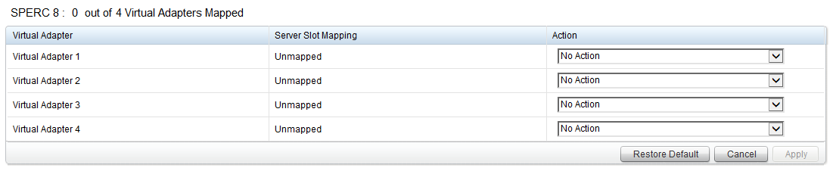

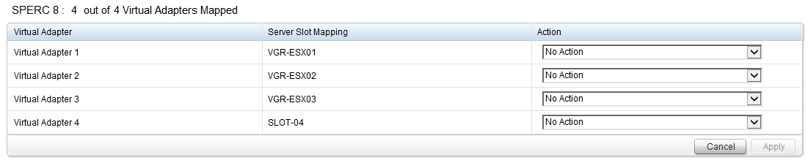

* In “Chassis Overview” > “Storage” > “Virtual Disks” under the “Assign” tab, now grant “Full Access” to all blade.
* VirtualDisk1R6: 1.50 TB (used for the vCenter, DC & templates)
* VirtualDisk2R6: 1.50 TB (used for servers)
* VirtualDisk3R6: 1.50 TB (used for clients)
* VirtualDisk4R6: 2.04 TB (used for the file server)

# Dell VRTX storage performance tweaks

In this section we will execute some VRTX specific performance tweaks. These tweaks will need to be applied on each ESXi server separately. Only applying them on a single ESXi can cause serious performance issues on the cluster.

Step by step procedure to be executed on each ESXi host:

* Connect the vSphere Client to the ESXi host.
  + In the “Inventory View”, select the host. Then select the “Configuration” tab. In the sidebar select “Software” > “Advanced Settings”.
  + Select “Disk” in the sidebar and scroll to Disk.DiskReservationThreshold and set the value to “1”.
* Open Putty and connect to the ESXi host.
  + Once connected, run “esxcli storage core device list”. This will display a list of storage devices. For all “DELL Serial Attached SCSI Disk” devices, copy the “naa.” identifier. Local disks should be ignored. The number of naa.identifiers which you need to copy equals the number of shared virtual disks created on the VRTX.
  + Now run “esxcli storage core device set --device <naa.idenfitier> --queue-full-sample-size 32 --queue-full-threshold 8 --sched-num-req-outstanding 128” where the <naa.idenfitier> is the value noted above. The command will provide no output. To verify correct execution, run “esxcli storage core device list” and verify that the following parameters are set for the “DELL Serial Attached SCSI Disk” devices:
    - Queue Full Sample Size: 32
    - Queue Full Threshold: 8
    - No of outstanding IOs with competing worlds: 128

# Dell430 / DL20 >> Configure all Datastores

Browse to vSphere host client >> X.X.X.247

Go to Storage >> Datastores

Rightclick the LocalDisk >> Rename

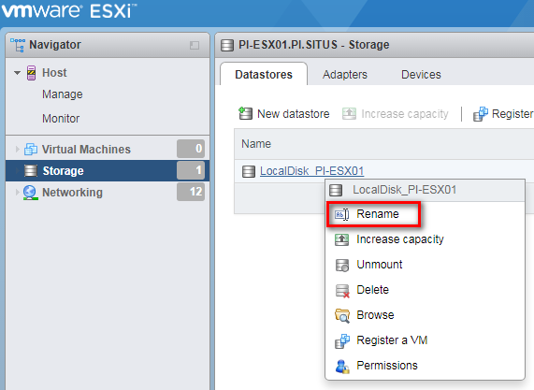

Rename disk to >> VirtualDisk1R6

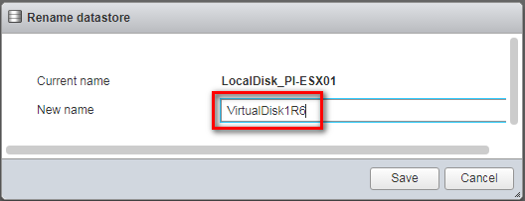

Putty >> SSH >> X.X.X.247

Login: root | Password: [admin password]

>> Esxcli storage core path list

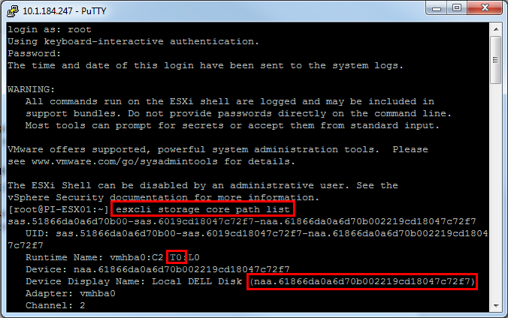

For all Local DELL Disks

>> compare the naa identifier when you create the datastores

>> Runtimename:

|  |  |  |  |  |
| --- | --- | --- | --- | --- |
| Sequence number | T0 | T1 | T2 | T3 |
| Virtual Diskname | VirtualDisk1R6 | VirtualDisk2R6 | VirtualDisk3R6 | VirtualDisk4R6 |

Repeat the following steps to create all 4 datastores:

Browse to vSphere host client >> X.X.X.247

Go to Storage >> Datastores >> New datastore

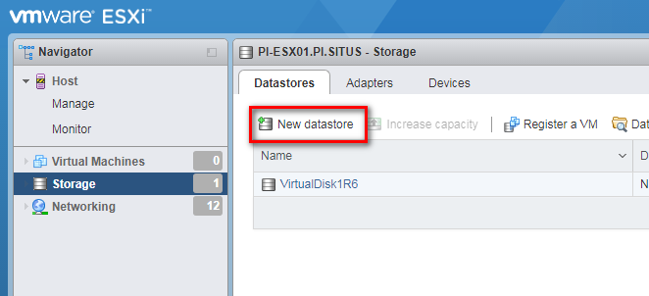

>> Create new VMFS datastore

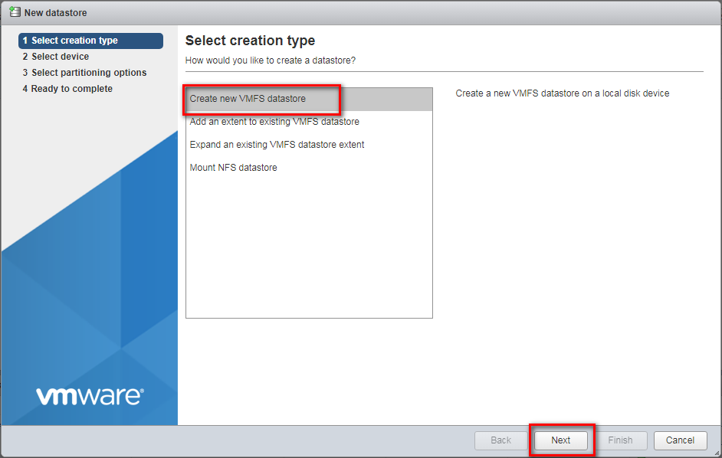

>> Name the device as mentioned in the table above

>> Select the DELL Disk by checking the naa identifier linked with the correct sequence numbers

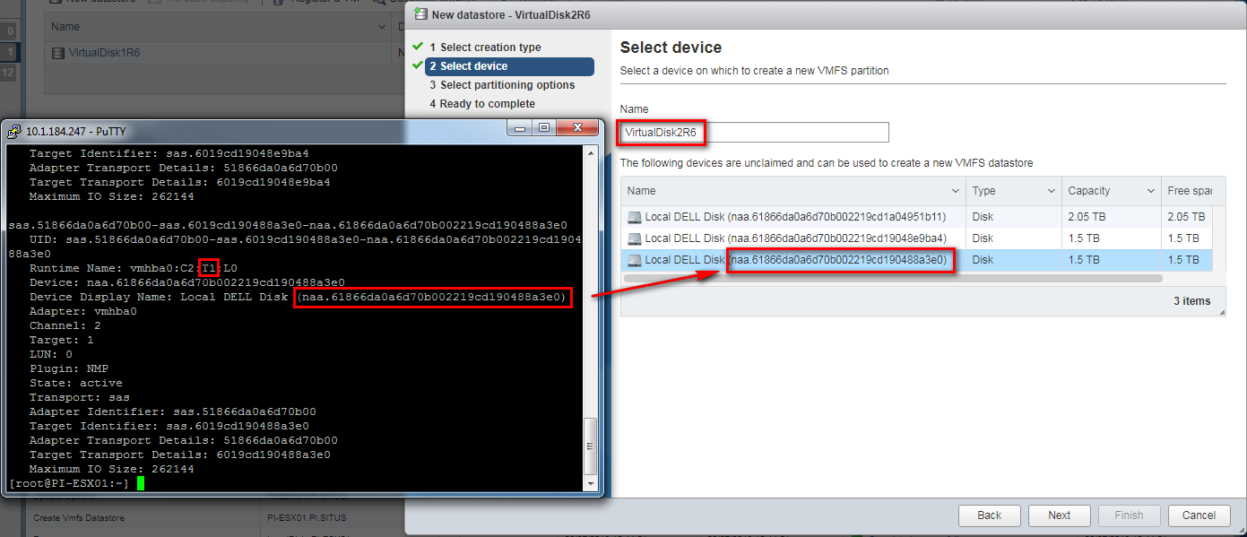

>> Use full disk || VMFS 5

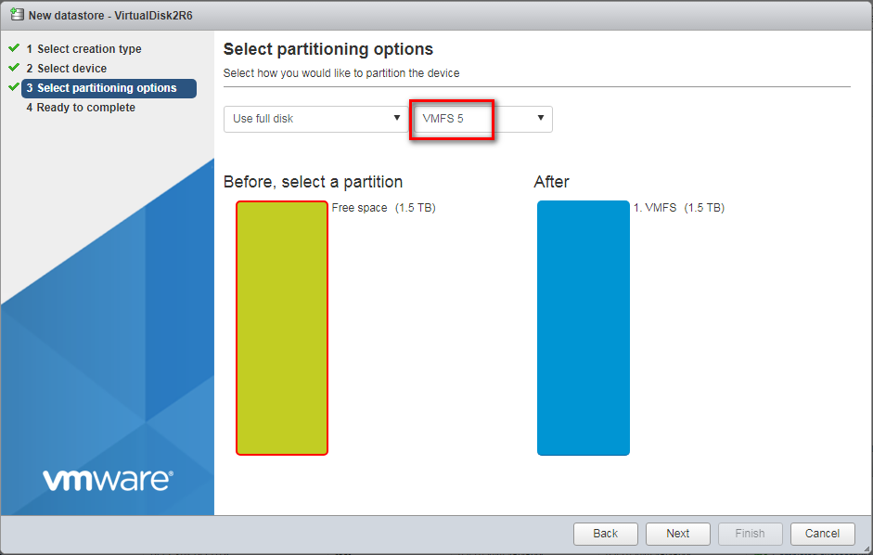

>> Finish >> Yes

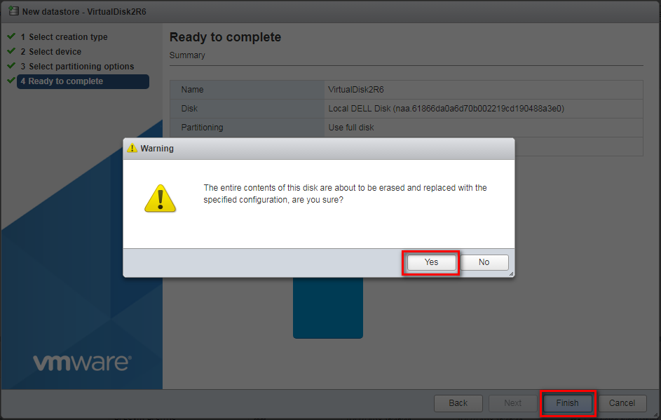

Click refresh when you created all 4 datastores to see if they were created

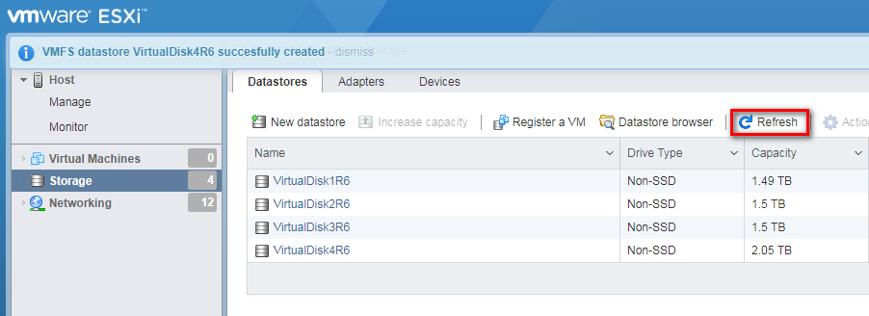

# VRTX >> ESXi Configure Datastores

In this section, we will add the datastores created on the IDRAC/ILO to the local ESXi installation. Copy the latest version of the “scripted install” scripts and modify the configuration.xml file.

Under ...\Scripted Install\vSphere 6.5 (1.1)\Deploy\ edit the Configuration.xml file in accordance with the comments present within the file. Do not edit the .txt or StartThisElevated files.

Step by step deployment procedure:

* If you do not have the script already running, execute your local copy of ...\Scripted Install\vSphere 6.5 (1.1)\Deploy\StartThisElevated.ps1 while elevating the script (run PowerCLI as administrator).
* You will be shown a numbered menu and an overview of the currently configured variables which will be used for the install.
* Run “*StartThisElevated.ps1*” script

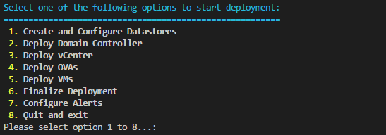

* Select option 1: *Create and Configure Datastores*.

# DC deployment

In this section we deploy the domain controller OVA and configure the domain.

Step by step deployment procedure:

* If you do not have the script already running, execute your local copy of ...\Scripted Install\vSphere 6.5 (1.1)\Deploy\StartThisElevated.ps1 while elevating the script (run PowerCLI as administrator).
* You will be shown a numbered menu and an overview of the currently configured variables which will be used for the install.
* Pick the “*Deploy Domain Controller*” menu option and press enter.
* The DC OVA will be deployed.
* The VM contains a number of configuration scripts that can be run to configure the domain automatically. However, you should always retrieve the latest DC configuration scripts from the fileshare. Consult the other documentation to learn more about the DC configuration steps and do not forget to execute them before continuing.
* Note: Be sure to wait long enough before executing the install & configure scripts. Your VM needs to reboot to run the customization script which is deployed together with your VM.

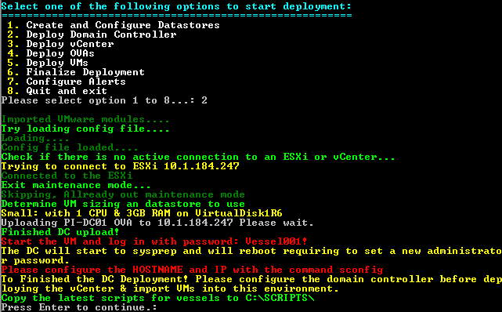

For detailed description of DC configuration, please consultJDN Standards - Domain Controller v1.1: <http://meso.jandenul.com/meso-webtop/drl/objectId/090236ed8452999b>

# VMWare vCenter appliance 6.5

In vSphere 6.5 the domain controller needs to be operational first!

In this section we deploy the VMWare vCenter appliance ova/ovf template to the shared storage of the first ESXi servers. The configuration is largely automated, but some steps cannot be scripted in version 5.5.

Once networking is set up, the appliance management interface can be accessed by surfing to its IP using https & port 5480. The settings in this interface will most likely not need to be changed. Most configuration will be done through the vSphere Web Client: https://<IP>:9443/vsphere-client/

Edit the Json file in ...\Scripted Install\vSphere 6.5 (1.1)\Deploy\

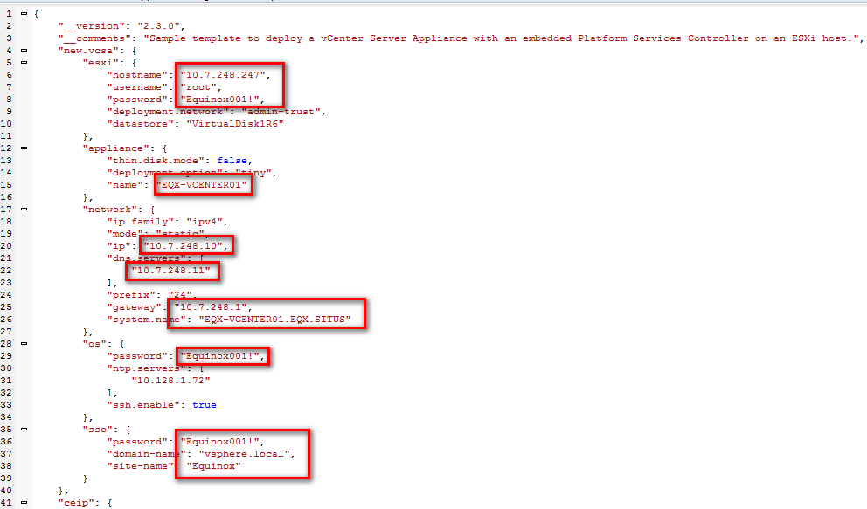

Check if the vCenter’s IP address is resolvable from the DC

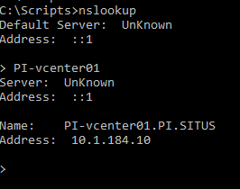

Step by step deployment procedure:

* Execute your local copy of ...\Scripted Install\vSphere 6.5 (1.1)\Deploy\StartThisElevated.ps1 while elevating the script (run PowerCLI as administrator).
* You will be shown a numbered menu and an overview of the currently configured variables which will be used for the install.
* Pick the “*Deploy vCenter*” menu option and press enter.

Enter [1] to accept thumbprint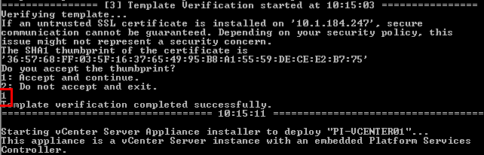

Press enter when the script asks for the amount of servers

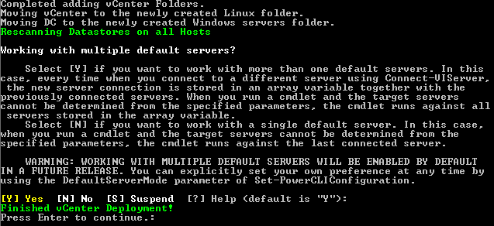

* The vCenter appliance will be deployed using your previously edited configuration. This will include adding the configured ESX servers into a cluster.
* Verify that the other servers have been added to the cluster by logging into the vCenter’s vSphere Web Client. For this, use the [administrator@vsphere.local](mailto:administrator@vsphere.local) user, since you will need the SSO administrator for steps further down. The root user does not have rights to see or modify SSO groups.
* Configure the Single Sign-On policies:
  + Go back to the home page of the vSphere Web Client [https://X.X.X.10]. Click “Administration” on the [Home button] menu bar. (Top Left)
  + Under “Administration” > “Single Sign-On” > “Configuration”, click tab “Policies” and then “Password Policies” & Edit. Configure:
    - Description: “JDN policy”
    - Maximum lifetime: 9999 days
    - Restrict re-use: 1 passwords
    - Maximum length: 20
    - Minimum length: 10
    - Characters: At least 0 special characters, 2 alphabetic, 1 numeric, 1 lower case, 1 upper case & 3 Identical adjacent characters.
  + Now click “Lockout Policy” & Edit. Configure:
    - Description: “JDN Policy”
    - Max failed attempts: 10
    - Time interval between failures: 10 minutes
    - Unlock time: 10 minutes
* Configure the Single Sign-On domain:
  + Under “Administration” > “Single Sign-On” > “Configuration”, click tab “Identity Sources”.
  + Select the line with “vsphere.local”.
  + Click “Set as Default Domain”.
  + This will allow “[administrator@vsphere.local](mailto:administrator@vsphere.local)” to log in as “administrator” instead. This also makes it easier for users which we will create in the vsphere.local SSO domain. However, the “root” account will now need to log in with “root@localos”.
* Create a new Access Control role:
  + Under “Administration” > “Access Control” > “Roles”, select the line with “Virtual machine power user (sample)”.
  + With the line selected, click the “Clone role action” icon.
  + Name the new role “Virtual machine power user”.
  + Select the new role and click “Edit”.
  + Under “Host” > “Configuration”, check the checkboxes for “Maintenance” & “Power”.
  + Press “Next” >> Finish.
* Configure the Single Sign-On users:
  + Under “Administration” > “Single Sign-On” > “Users and Groups”, click tab “Users”.
  + Make sure Domain “vsphere.local” is selected.
  + Click the + sign to create a local user:
    - User name: adl_local
    - First name: ADL
    - Last name: Local
  + Click the + sign to create a TSE user:
    - User name: adl_tse
    - First name: ADL
    - Last name: TSE
  + Click the + sign to create a backup service user:
    - User name: srv_backup
    - First name: Service User
    - Last name: Backup
  + Click the + sign to create a UPS service user:
    - User name: srv_ups
    - First name: Powerchute
    - Last name: UPS
  + Click the “Groups” tab.
  + Select the “Administrators” group.
  + In the “Group Members” pane, click the + sign to add users to the group.
  + Add “adl_tse”, “srv_backup” & “srv_ups” users and click OK.
* Assign Permissions:
  + Menu >> VMs amd Templates >> [Select vCenter] >> go to permissions

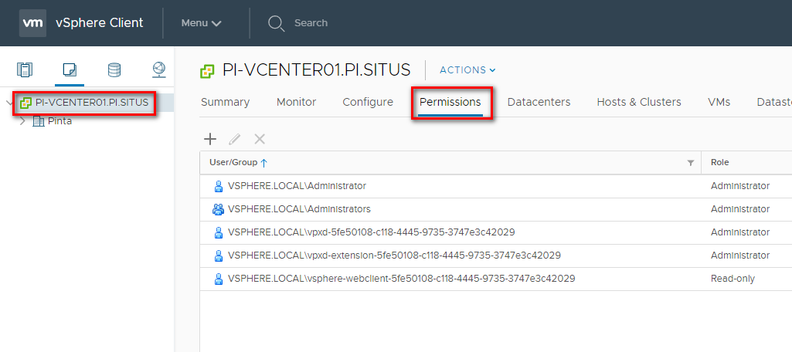

* + Click the + sign to add a user.
    - Click “Add...” under the “Users and Groups” section and enter:
      * Domain: VSPHERE.LOCAL
      * User/Group: adl_local
      * Role: Virtual machine power user
      * Click “OK”.
  + Click the + sign to add a user.
    - Click “Add...” under the “Users and Groups” section and enter:
      * Domain: VSPHERE.LOCAL
      * User/Group: adl_tse, srv_backup & srv_ups
      * Role: Administrator
      * Click “OK”.
  + Browse to vCenter appliance page (https://X.X.X.10:5480) and log in with root & the according password.
    - Click on “Administration”
    - Change the Password Expiration Settings
    - Root password expires -> No
    - Submit

# Template/OVA deployment

In this section we deploy the OVAs which are present on the network share and convert them into ready to use templates. \\Jdn-file01\ict_new_standard_sites_vessels\Templates\Current

Step by step deployment procedure:

* If you do not have the script already running, execute your local copy of ...\Scripted Install\vSphere 6.5 (1.1)\Deploy\StartThisElevated.ps1 while elevating the script (run PowerCLI as administrator).
* You will be shown a numbered menu and an overview of the currently configured variables which will be used for the install.
* Pick the “*Deploy OVAs*” menu option and press enter.
* The OVAs will be deployed and subsequently converted to templates.

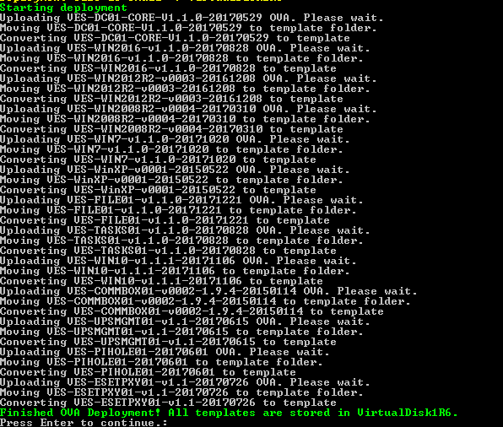

* Verify that the necessary templates were made available
* [https://X.X.X.10] >> Storage >> VirtualDisk1R6 >> Datastore Browser >> Select VirtualDisk1R6

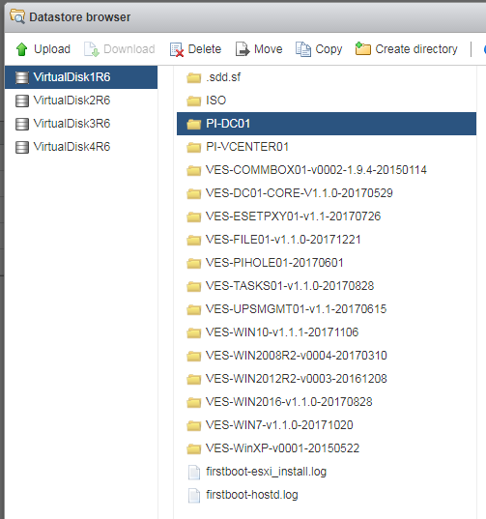

# ISO deployment

Go to the first shared datastore using your vSphere host client [https://X.X.X.10]. Create a new folder named “ISO”.

Storage >> VirtualDisk1R6 >> Datastore Browser >> Select VirtualDisk1R6 >> Create directory

Manually upload the useful ISOs available in ...\Software\Current\ to the datastore. It is especially important to upload the Windows ISOs.

Upload the following files:

* Veeam9.5
* Windows Server 2016
* Windows 10

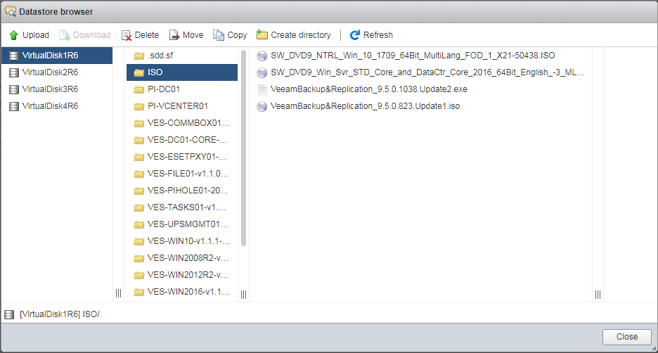

# VM deployment

In this section we deploy a number of VMs, put them in the right folders and where possible join them to the available domain.

Edit the xml file to add additional VMs for ships [...\Scripted Install\vSphere 6.5 (1.1)\Deploy\]

Example:

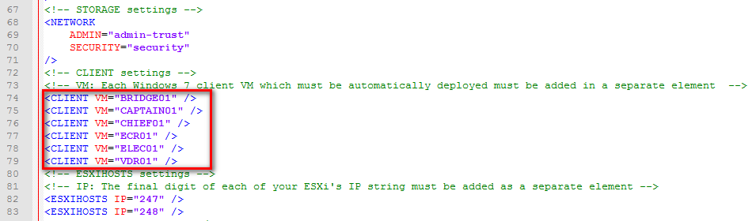

Step by step deployment procedure:

* If you do not have the script already running, execute your local copy of ...\Scripted Install\vSphere 6.5 (1.1)\Deploy\StartThisElevated.ps1 while elevating the script (run PowerCLI as administrator).
* You will be shown a numbered menu and an overview of the currently configured variables which will be used for the install.
* Pick the “*Deploy VMs*” menu option and press enter.
* VMs will now be deployed & started. Keep in mind that joining them into the domain (if available) can take up to 15 minutes after deployment. To join the domain, they will restart automatically. Please do not interrupt their configuration until they have joined the domain (if applicable).
* Install RSAT tools on MGMT01 through VMware Remote Console [\\Jdn-file01\ict_new_standard_sites_vessels\Software\Current\Windows\RSAT Tools]
* Once the VMs have joined the domain, do not forget to move them to the correct OUs in Active Directory << start VMware Remote Console >> Administrative Tools >> AD Users and Computers >> Add the DC
* Reboot all Windows VMs beside DC
* Your MGMT01 VM will have 2 NICs, only one of which has an IP assigned. You can manually configure the second NIC as:
  + IP: 172.16.3.20
  + Mask: 255.255.255.128
  + Do not configure a gateway or DNS on this NIC
* Install the highest version of TeamViewer Host on MGMT01 [\\jdn-file01\Software$\Software - Windows Official\Teamviewer] (accept all popups)
* When the TeamViewer entry is added change Name and set the description to the destination folder

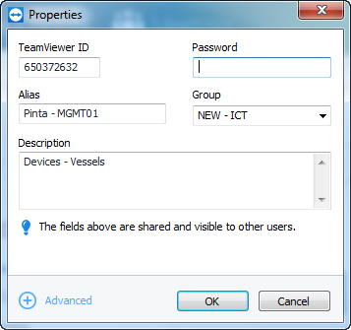

* Once all the VMs have joined the domain, now run the “Finalize Deployment” option of the PowerCLI script. This will set the time zone to UTC, as is standard for ships. For offices & sites, using UTC is allowed, but other time zones can be configured. To do this, modify the $timeZone variable in the $SETTIMEZONESCRIPT string. Be careful, “CET” is not a valid entry. You need to use the syntax found in tzutil.exe /l. Example: “CET” translates to “Romance Standard Time”.

# Domain maintenance

In the selected OUs there are users with Temp passwords, delete the description and change the password

Add all users to RDMs

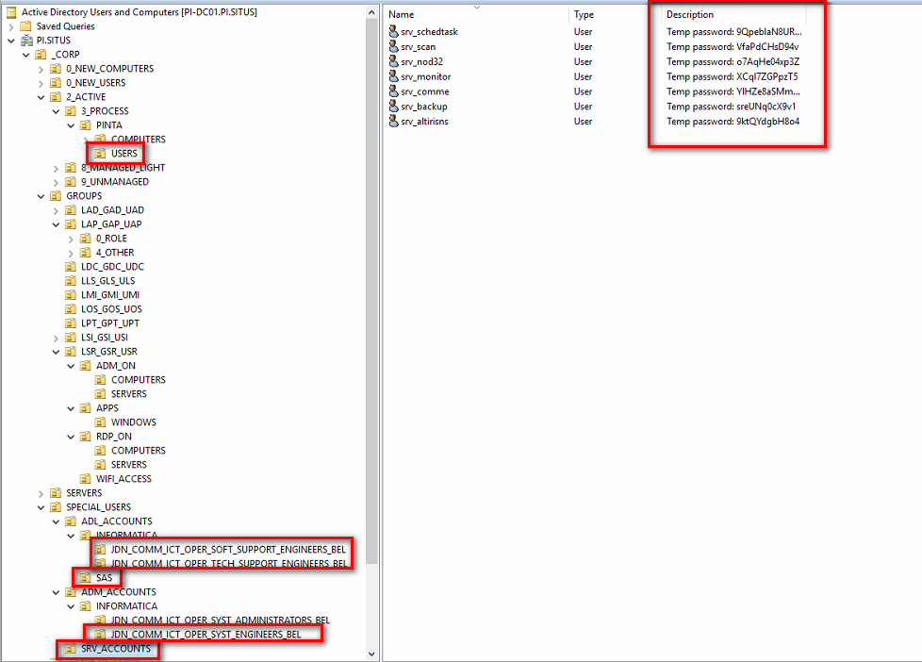

Place the computer object in the correct OU

> Put MGMT VM in XX.SITUS/_CORP/2_ACTIVE/8_MANAGED_LIGHT/PI_COMM_SHARED_SERVICES/PI_COMM_SS_ICT_OPER_MGMT_PCS/COMPUTERS/

> Client VMs in XX.SITUS/_CORP/2_ACTIVE/3_PROCESS/PINTA/COMPUTERS/

> Server VMs in XX.SITUS/_CORP/SERVERS/MANAGED/

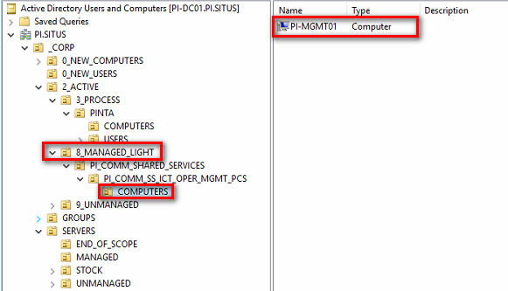

# Autostart VM’s - SITUS

In case of a clean shutdown of the virtual machines triggered by the PowerChute environment, VM’s should automatically boot after blades get powered back on.

The only user interaction (elec e.g.) should be powering on the chassis, followed by powering **all** blades.

### Configuring XX-MGMT01

Copy the **‘Operations’** **folder**:

[\\Jdn-file01\ict_new_standard_sites_vessels\Scripted Install\Autostart (1.1)\](\\\\Jdn-file01\\ict_new_standard_sites_vessels\\Scripted Install\\Autostart (1.1)\\)

To the management VM at the following location:

**C:\Program Files (x86)\JDN\**

! Run the script [ConfigureAutostart.ps1] as administrator !

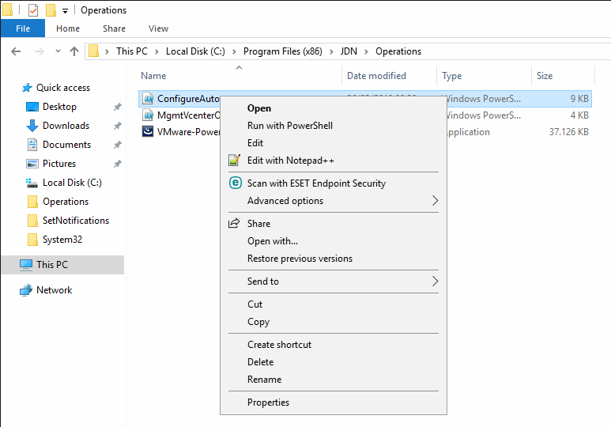

Run the Installation Wizard for PowerCLI by using the default values and accepting the user agreements.

Provide values for the parameters Vcenter IP and Vcenter administrator password.

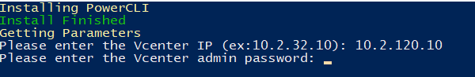

! Always put the domain in front of the username !

After this, 2 scheduled tasks will be created. Provide domain admin credentials:

1. ‘***Boot VMs’***: Will run after startup of XX-MGMT01 and power on all VM’s
2. ‘***ESX01Check***’ : Runs every hour to make sure XX-VCENTER01, XX-DC01 and XX-MGMT01 are running on the first ESX host.

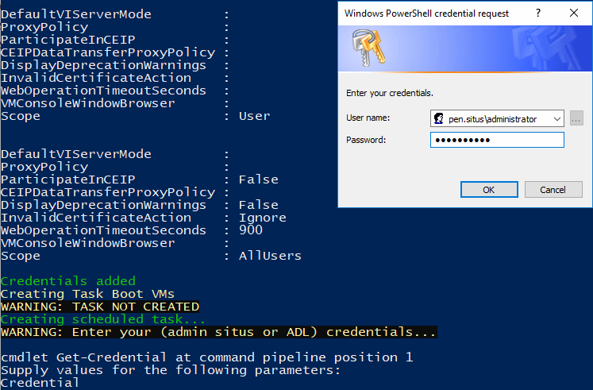

**Open Task Scheduler and make sure both above tasks are present.**

### Configure ESX

*Autostart should be configured using the* ***flash*** *version of the vCenter webpage,* ***NOT*** *HTML5.*

Logon to first ESX host (https://10.xx.xx.247) and navigate to

Host > Manage > System > Autostart

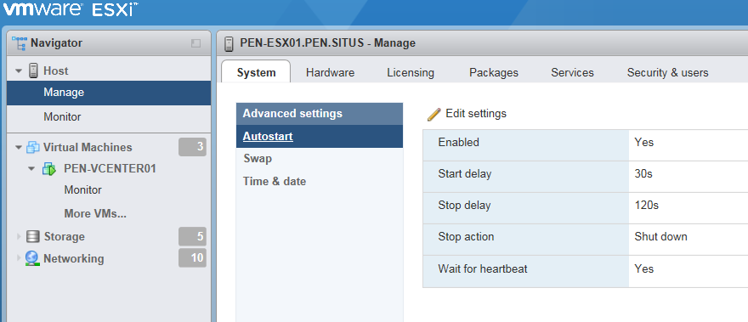

Click ‘Edit settings’ and configure following settings:

Enabled: Yes

Start delay: 30 seconds

Stop delay: 120 seconds

Stop action: Shut down

Wait for heartbeat: Yes

Navigate to the Virtual Machines overview, right-click XX-VCENTER01 and select Autostart > Enable. No need to configure custom Autostart settings on this VM.

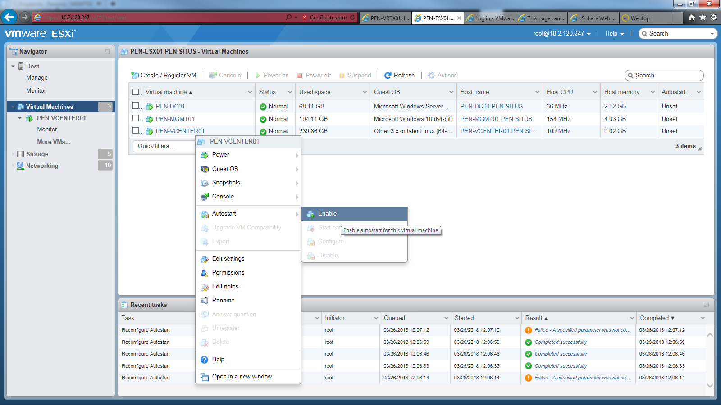

Right-click XX-DC01 and enable autostart.

Right-click XX-MGMT01 and enable autostart. Configure autostart VM options and set following values:

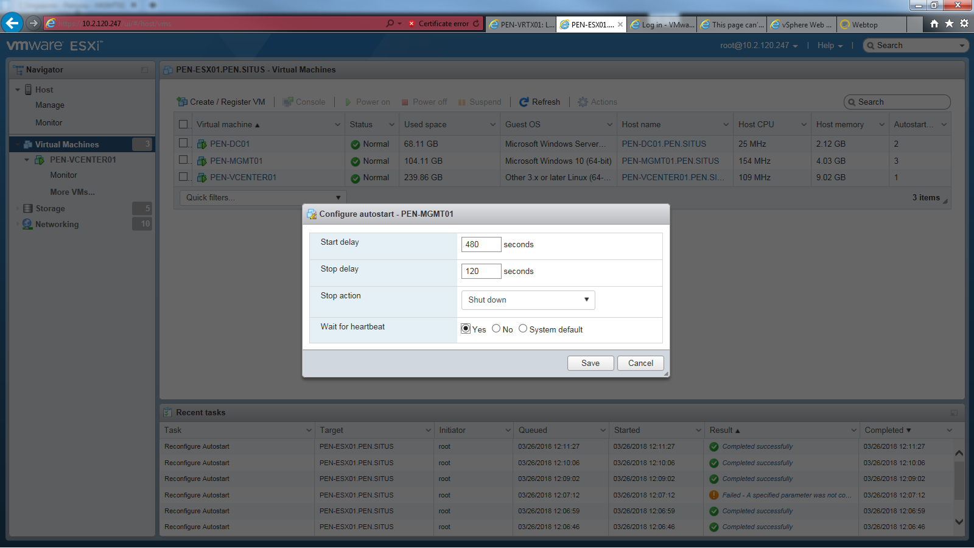

Make sure the Autostart order is set as shown below, this can be changed by right-clicking a VM and select Autostart > Start earlier or Start later:

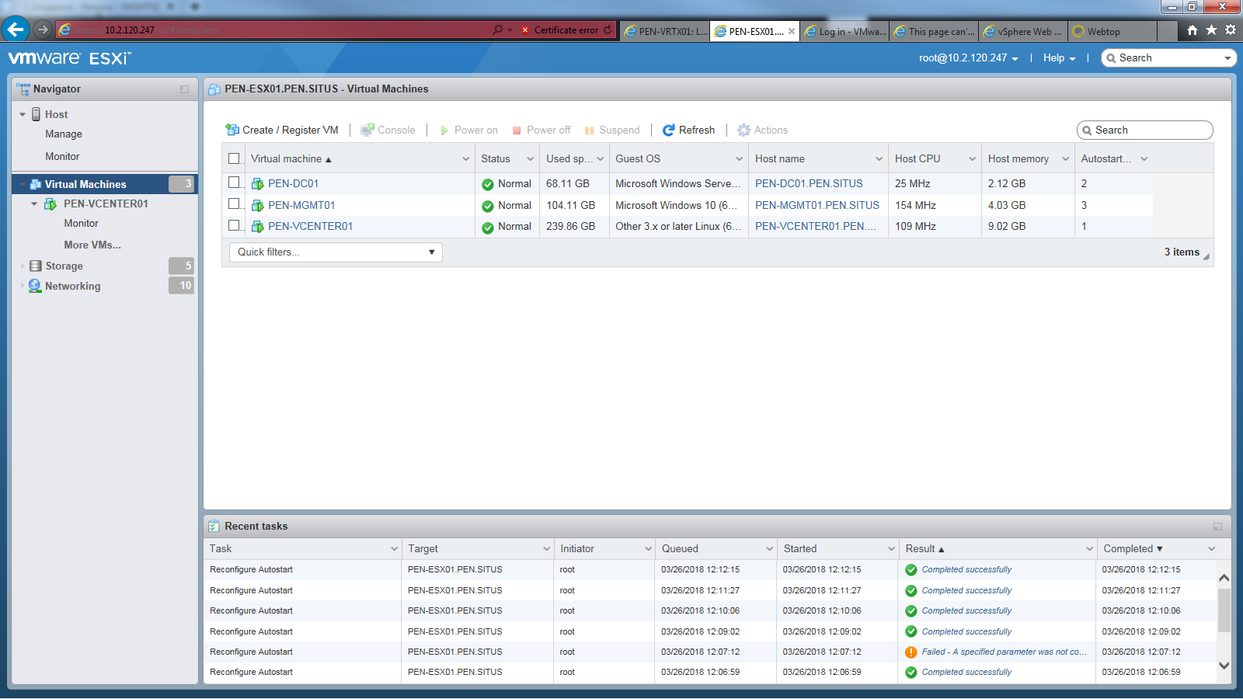

1 -> XX-VCENTER01 2 -> XX-DC01 3 -> XX-MGMT01

### Test

The autostart setup can be tested as followed:

1. Perform a shut down guest on all VM’s **except** XX-VCENTER01.
2. Once all Vm’s are in a powered off state, shut down the VCenter VM.
3. Open the (VRTX) iDRAC webpage and perform a Graceful Shutdown of **all** blades.

(Chassis Overview > Server Overview > Power > Control)

1. Once Power state has changed to ‘Off’ power the blades back on.

After 10 minutes, the VCenter web client should be available again where it’s possible to monitor the power state of all VM’s. Within 20 minutes, all VM’s should be up and running.

# Autostart VM’s – JDN Integrated

In case of a clean shutdown of the virtual machines triggered by the PowerChute environment, VM’s should automatically boot after blades get powered back on.

The only user interaction (elec e.g.) should be powering on the chassis, followed by powering **all** blades.

**Logon to the mgmt virtual machine as srv_schtsk_xx user**

### Configuring XX-MGMT01

Copy the **‘Operations’** **folder**:

[\\Jdn-file01\ict_new_standard_sites_vessels\Scripted Install\Autostart (1.1)\](\\\\Jdn-file01\\ict_new_standard_sites_vessels\\Scripted Install\\Autostart (1.1)\\)

To the management VM at the following location:

**C:\Program Files (x86)\JDN\**

! Run the script [ConfigureAutostart.ps1] as administrator ! (Open PS as admin and navigate to the Operations folder)

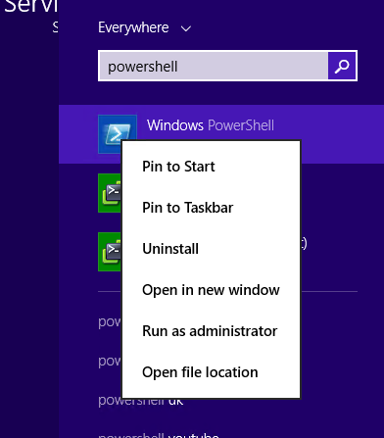

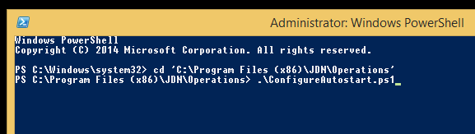

After this, 2 scheduled tasks will be created.:

1. ‘***Boot VMs’***: Will run after startup of XX-MGMT01 and power on all VM’s
2. ‘***ESX01Check***’ : Runs every hour to make sure XX-VCENTER01, XX-DC01 and XX-MGMT01 are running on the first ESX host.

**Open Task Scheduler and make sure both above tasks are present.**

### Configure ESX

*Autostart should be configured using the* ***flash*** *version of the vCenter webpage,* ***NOT*** *HTML5.*

Logon to first ESX host (https://10.xx.xx.247) and navigate to

Host > Manage > System > Autostart



Click ‘Edit settings’ and configure following settings:

Enabled: Yes

Start delay: 30 seconds

Stop delay: 120 seconds

Stop action: Shut down

Wait for heartbeat: Yes

Navigate to the Virtual Machines overview, right-click XX-VCENTER01 and select Autostart > Enable. No need to configure custom Autostart settings on this VM.



Right-click XX-DC01 and enable autostart.

Right-click XX-MGMT01 and enable autostart. Configure autostart VM options and set following values:



Make sure the Autostart order is set as shown below, this can be changed by right-clicking a VM and select Autostart > Start earlier or Start later:



1 -> XX-VCENTER01 2 -> XX-DC01 3 -> XX-MGMT01

### Test

The autostart setup can be tested as followed:

1. Perform a shut down guest on all VM’s **except** XX-VCENTER01.
2. Once all Vm’s are in a powered off state, shut down the VCenter VM.
3. Open the (VRTX) iDRAC webpage and perform a Graceful Shutdown of **all** blades.

(Chassis Overview > Server Overview > Power > Control)

1. Once Power state has changed to ‘Off’ power the blades back on.

After 10 minutes, the VCenter web client should be available again where it’s possible to monitor the power state of all VM’s. Within 20 minutes, all VM’s should be up and running.